

Churchend Primary Academy
Usk Road, Tilehurst, Reading, RG30 4HP
Tel: 0118 937 5450
admin@churchendacademy.com
www.churchendacademy.com
Headteacher: Mrs L Slocombe
Dear Parents and Carers,
Welcome to Churchend!
We are thrilled to welcome you and your child to our Reception setting and to a wonderful learning adventure in the Early Years Foundation Stage (EYFS). We are looking forward to getting to know your family and watching your child grow and flourish with us this year. The EYFS is a special time of curiosity, discovery, and play-based learning, and we are committed to providing a safe, nurturing, and inspiring environment for every child. We believe in building a strong partnership with you, and we value your involvement in your child's education every step of the way.
Some key information:
Our Daily Routine
- Arrival and Registration: School starts at 8.40am. Please bring your child to the entrance next to the school hall, where members of the team will be waiting to welcome them.
- Collection: At the end of the day, at 3.15pm, we will dismiss your child from the classroom doors. To ensure your child's safety, please let the school office know if someone different will be collecting them.
- Learning Through Play: Our days are filled with a mix of adult-led and child-initiated activities both indoors and outdoors. We follow the children's interests and facilitate learning through play.
- Snack Time: We have a designated snack time each day. Children receive a free healthy snack (e.g., fruit or vegetables) provided by the school.

What to Bring to School
Please help us by ensuring your child has the following items with them each day, all clearly labelled with their name:
- Water Bottle: Children should have a full water bottle with them every day.
- Spare Clothes- Please pack a spare set underwear in your child’s bag, in case of accidents. We have a limited supply of replacement clothes in school.
- Outdoor Wear: As we love to play outside in all weathers and have a weekly Forest School session, please ensure your child has a waterproof coat and wellington boots. These can be left on their pegs at school.

Communication
Open communication is valued, and the school is always available to help.
- Website: https://www.churchendacademy.com
- In-person: Quick chats are available at drop-off and collection times. For more in-depth conversations, please arrange a meeting through the school office.

P.E
P.E for both classes is every Monday morning. Please send your child to school in their P.E kit. They will remain in their P.E kit for the day.

RWI Phonics/ Reading homework:
The children will start with this programme on Monday 15th September. Each day they will learn a new sound from Set 1. On Fridays, they will bring home copies of the sounds/ matching pictures learnt during the week, and a set of worksheets to practice what they have learnt. These sheets will be checked every Friday. Please ensure that these are returned. The sounds and picture cards can be kept at home for daily practice.
Once the children know enough sounds to start blending into words, they will bring home their first reading books and reading record. We ask that children read every day at home and that a short comment is written in their reading record and signed. The children will also go home with a library/pleasure book to enjoy at home. This could perhaps be used as a bedtime story.

Our special class toy:
Each class has a special soft toy and this will be sent home each week on Fridays, with a different child. Included with the soft toy will be a story book to enjoy together, and an exercise book in which you will find a sheet to be filled in with a brief comment on how the book was enjoyed (written by the adult, of course) and a space for your child to either draw something related to the book e.g. main character, or if you are able, a photo of your child with the book. Please make sure that the bag containing everything is returned to school the following Thursday.

Forest School
The Reception children will be out in the Forest school every Friday afternoon. This is an important part of their learning and of our curriculum. We go out in all weathers, where appropriate, and children will need their wellies and raincoats when the rain arrives.
Important Reminders
We are a nut free school. Packed lunches should not include nuts e.g. nut snacks or peanut butter.
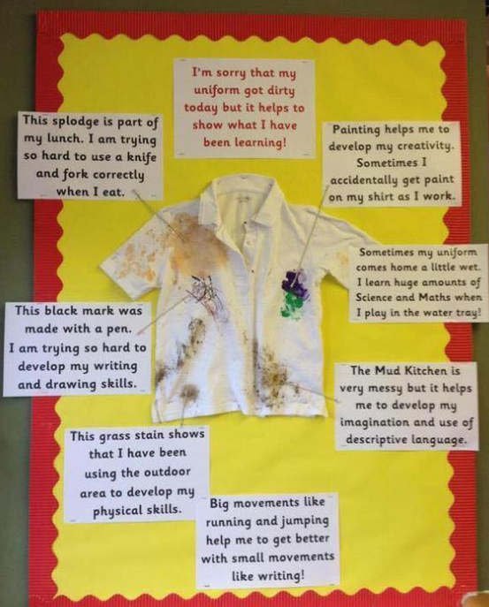
We do try very hard to help the children to keep their uniform clean, however in Reception we do learn through play and sometimes the uniform can get a little messy. The children are provided with, and encouraged to wear aprons during creative, messy and water-based activities.

We know that the beginning can feel quite overwhelming but please be reassured that we are here to make your child’s transition (and yours) into Reception a happy and fulfilling one.

Kind regards,
Mrs. Evelyn Swart
EYFS Phase Lead

