Did you know?
Exercise can help with good sleep but it shouldn’t be too near to bedtime.


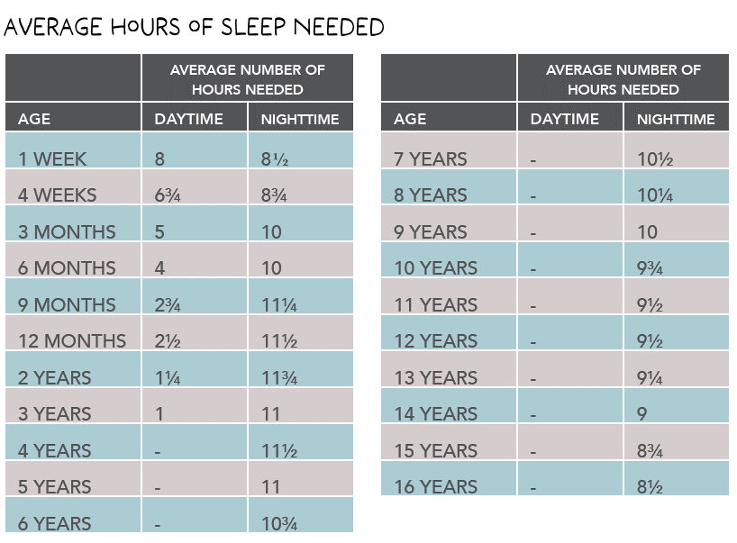
Sleeppppppp

Sleep is essential to our physical, emotional and mental wellbeing.

Poor sleep habits from an early age can lead to long-term sleep problems.



Tried and tested strategies:
- A regular bedtime routine.
- Calming activities and no screen time in the hour before ‘sleep time’.
- A warm bath 30 minutes before bed.
- A story or some independent reading.

Screen Time 
According to research using a screen before bed can double the length of time that it takes to fall asleep.

We have found further useful information and a new sleep ebook for parents, (particularly those who have a child who struggles to get good quality sleep) at:
thesleepcharity.org.uk

Did you know?
It has been said that humans can survive for three times as long without food than without sleep!

